EXPERIMENT – 14
Simple programming using REPEAT and WHILE REPEAT:
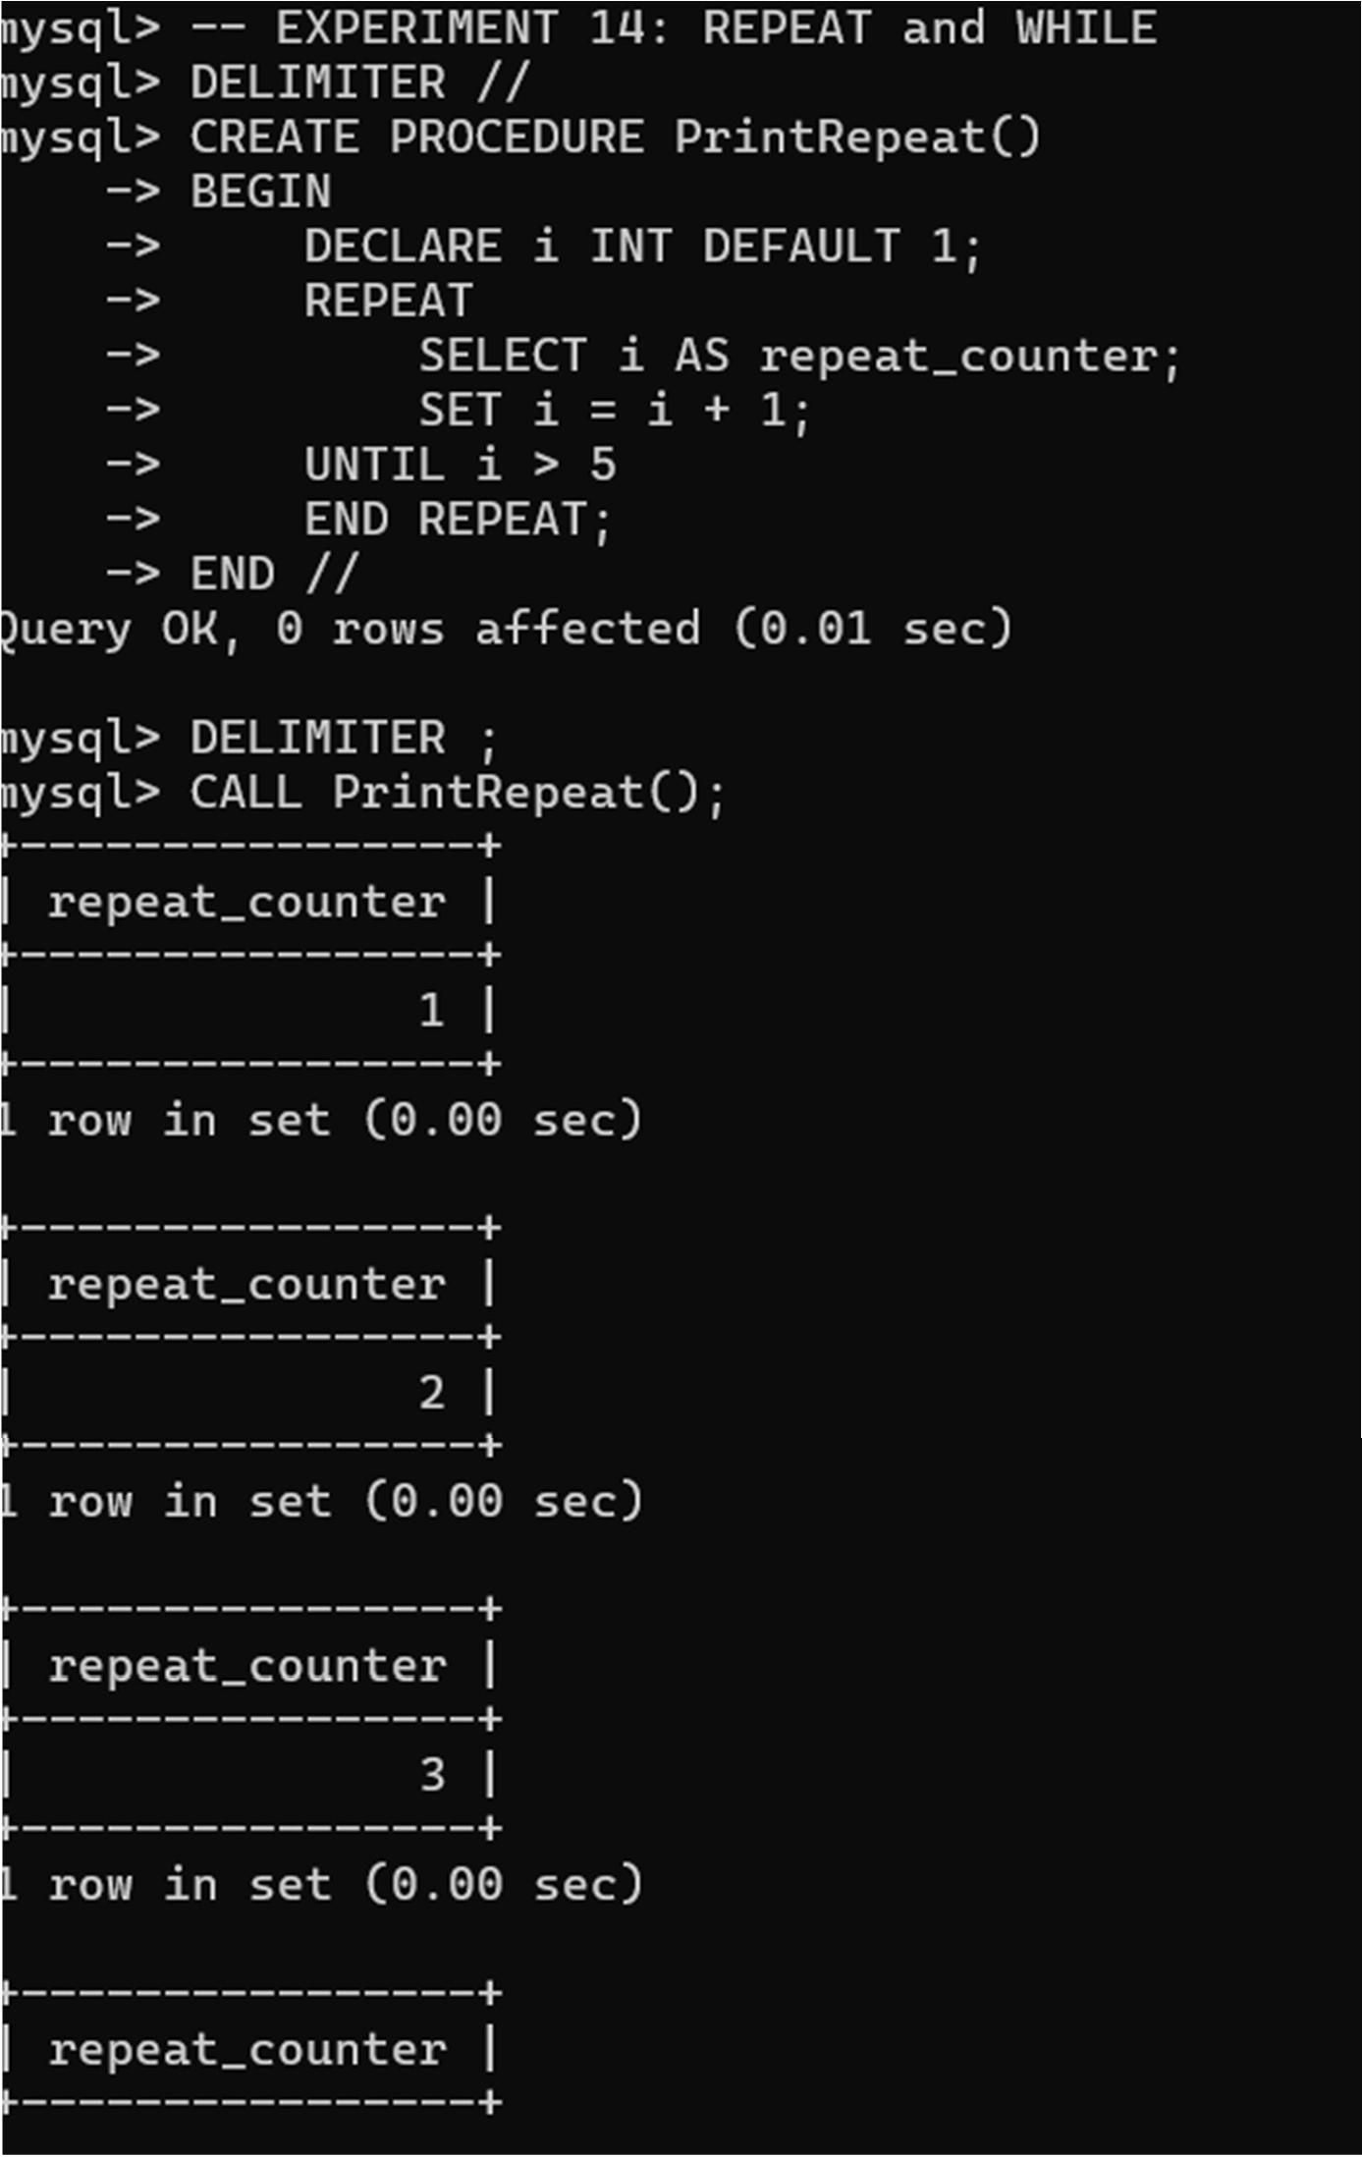

WHILE:
